**Graphql API**

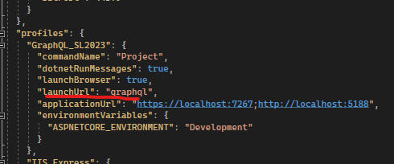

Set initialize url.

Use case: swagger,graphql

Setup client Strawbelly.Shake

1. Create Console Application

2. Dotnet new tool-manifest

3. dotnet tool install StrawberryShake.Tools –local -version < 13

4. Nuget install StrawberryShake.CodeGeneration.CSharp.Analyzers – same strawberryshake tools version

5. Dotnet graphql init <https://localhost:7267/graphql>

6. Install Strawbelly.Http.Transport & DependencyInjection & StrawberryShake.Transport.Http & StrawberryShake.Transport.WebSockets

Dotnet graphql update

* Update graphql schema.graphql